CENTER FOR CONTINUING EDUCATION; JAMESTOWN COMMUNITY COLLEGE

BASIC EMERGENCY MEDICAL TECHNICIAN - AFFILIATED
Thursday, January 17 through Thursday, June 20 2019 (State Written Exam)

THIS WILL BE THE ONLY ORIGINAL EMT CLASS AT JCC IN 2019

CLASS DAYS/TIMES: 6:30 PM to 9:30 PM, Mondays/Thursdays AND AT LEAST 3 SATURDAYS;
- Saturday Class Dates (TBA).
- ALL CLASS DATES ARE MANDATORY – Must be able to make Saturday classes

LOCATION: Jamestown Community College, ARSC Building, Room 344

INSTRUCTOR
COORDINATOR: Ron Hasson, NREMT-P, CIC; Coordinator of EMT Training – Jamestown Community College

Special Note for those wishing to RECERTIFY – CLASS START DATE IS Thursday January 3rd:
Those wishing to recertify by taking the entire Basic/Original class will need to register for the Refresher EMT class first. You cannot just re-take the EMT course under state rules. Students in this category will be merged to the Basic/Original class the second week of this course. To obtain an EMT Refresher class application, contact your fire chief or call JCC at 716-338-1334.

COURSE REQUIREMENTS:

ELIGIBILITY/PRE-REQUISITES: Upon acceptance to the Basic EMT Program, all prospective students for EMT Basic/Original (not Refresher) will be required to take JCC’s Placement test for reading/math unless acceptable proof is submitted as follows: Associates Degree or higher; proof of present or past enrollment in a college (indicating a test has already been taken). Acceptable forms of proof: unofficial transcript or copy of diploma indicating MAT 0500 or greater and a college level reading score: Accuplacer 80+.

The course’s tuition will be paid by the state for those meeting the eligibility requirements (Paid professional ambulance technicians and/or volunteer fire and ambulance personnel - those actively working with a fire department or other EMS agency in Chautauqua/Cattaraugus County have priority over other applicants and the tuition will be paid by the state).

Books/Supplies: REQUIRED: Emergency Care 13th Edition (ISBN 978-013-4024554) – APPROXIMATE COST – $135
Workbook - (ISBN 978-013-4010731) APPROXIMATE COST $76
A CPR class must be taken outside of class during the same semester as the class. DO NOT take a CPR class before this course starts – State rules would require you to re-take CPR

Attendance: 100% attendance is required for all students. Only limited make-up sessions are allowed

Eligibility for State Certifying Exam: Students must pass all aspects of the course to be eligible to sit for the state certifying Exam. In addition, any unpaid balances owed to Jamestown Community College must be paid in full prior to any test date (Practical Skills Exam or State Exam).

Physical Condition: Some EMT training is strenuous. Applicants should consult their physician if conditions exists that may prevent them from full participation.

Proof of Immunizations: Students MUST provide proof of immunization from Rubella and Rubeola, a negative TB test and a qualifying physical exam to both the college health center and UPMC Chautauqua WCA hospital where they will be doing observation time. More will be explained the first class night.

ELIGIBILITY: Applicants MUST BE:
- 18 years of age or greater in the month of the State Exam Date (June 2019).
- Physically able to function as an EMT, meeting ADA requirements
- Able to read at least at the 11th high school grade level
- Those with criminal convictions of any type may not be allowed to be certified, pending investigation by the DOH
- Not be monetarily indebted to the college

Complete and return attached application by December 20, 2018 and registration forms by Monday, January 14, 2019.
JCC REGISTRATION PACKET IS BELOW.

Jamestown Community College – Jamestown Campus

BASIC EMERGENCY MEDICAL TECHNICIAN
EMS Affiliated Course Application

Thursday, January 17 through Thursday, June 20, 2019 (State Written Exam)

~~~~~~~~~~~~~~~~~~~~~~~~~~~~~~~~~~~~~

ALL INFORMATION BELOW IS REQUIRED:

FIRST/LAST NAME______________________________ MAIDEN NAME______________________ Date of Birth________________

STREET_______________________________________ CITY________________________ STATE_______ ZIP__________________

HOME PHONE_____________ CELL PHONE___________ FIRE COMPANY AFFILIATION__________________________________

~~~~~~~~~~~~~~~~~~~~~~~~~~~~~~~~~~~~~

Complete and return this application by December 20, 2018:

To: Jamestown Community College
Center for Continuing Education
525 FALCONER ST., PO BOX 20
JAMESTOWN, NY 14701

Or Fax to: (716) 338-1456

Once this application is received, you will be mailed a REGISTRATION PACKET with a “return by date”
as well as the policies/procedures required and if necessary, JCC Placement Testing.

Note:

- The college reserves the right to exclude students who have previously been declared academically ineligible, or those who are indebted to the college. When there are more than 35 applications, enrollment may be assigned on a priority basis per guidelines established by the Chautauqua County EMS Council.
- The state Department of health covers the tuition only, of those applicants who are actively working with a certified New York State EMS Squad.

The college reserves the right, whenever it deems advisable, to change its schedule of tuition and fees; to withdraw, cancel, reschedule, or modify any course, program of study, degree, requirement or policy. Jamestown Community College is sponsored by a regional board of trustees representing Cattaraugus County, Chautauqua County, and the City of Jamestown. Jamestown Community College does not discriminate on the basis of color, sex, sexual orientation, race, creed, religion, national origin or citizenship, age, marital status, military status, disability, family status, domestic violence victim status, arrest or conviction record, or predisposing genetic characteristics. This policy applies to access to all activities and programs under the college sponsorship as well as to application and selection for admission, employment, and all other personnel procedures within the college. This material can be made available in alternative media upon request for those with disabilities.

ATTACH THIS CHECKLIST TO YOUR COMPLETED FORMS

And return to JCC
no later than January 14, 2019:

Jamestown Community College
Center for Continuing Education (EMT Original Program)
525 Falconer Street
Jamestown, NY 14701
(716) 338-1334

NAME_____________________________________

____Student Data Form

____Certificate of Residency Form

____Immunization Record (brochure enclosed) – I’ve read the brochure and will submit records to JCC’s
Health Center as indicated in the brochure.

____Placement Test or Acceptable Proof go to http://placementtesting.sunyjcc.edu/ to register for
placement testing

____Proof Enclosed with all other forms

____I’ve registered for a Placement Test on:_______________________________ (date)
ALL PLACEMENT TESTS/RETESTS MUST BE TAKEN BY FRIDAY, January 14, 2019 (OR PROOF TO WAIVE THE TEST MUST BE SUBMITTED BY THIS TIME/DATE).

____ I fall under the NYSDOHEMS Affiliation Tuition Reimbursement and therefore my tuition will be
reimbursed by the State

Name of Fire Company you are affiliated with______________________________

_____Instructor Permission Card (if you are not eligible for the NYSDOHEMS Affiliation Tuition Reimbursement) - (Only needs to be submitted if you are a full time student enrolled in more than 18 credit hours.)

_____Tuition for Self Pay Students (If you are not eligible for the NYSDOHEMS Affiliation Tuition Reimbursement)

_____$204/cr. hr. plus college fees (NYS resident for at least 1 year)

_____$408/cr. hr. plus college fees (NYS resident less than 1 year)

Financial Aid – if you are seeking Financial Aid for this class, you MUST DO THE FOLLOWING:
Apply to JCC and be accepted into a JCC degree program; Admissions Office (COCE Building) - you must be enrolled in a degree program and be matriculated as a full time student. Otherwise this class is not eligible for financial aid. To Apply for Financial Aid (COCE Building) – complete your online FAFSA Application
If YOU ARE A FULL-TIME JCC STUDENT - ALL FINANCIAL AID MUST BE 100% IN PLACE PRIOR TO MONDAY, January 14, 2019 OR PAYMENT IN FULL WILL BE REQUIRED BY NOON ON MOVDAY, January 14, 2019.
NO EXCEPTIONS.

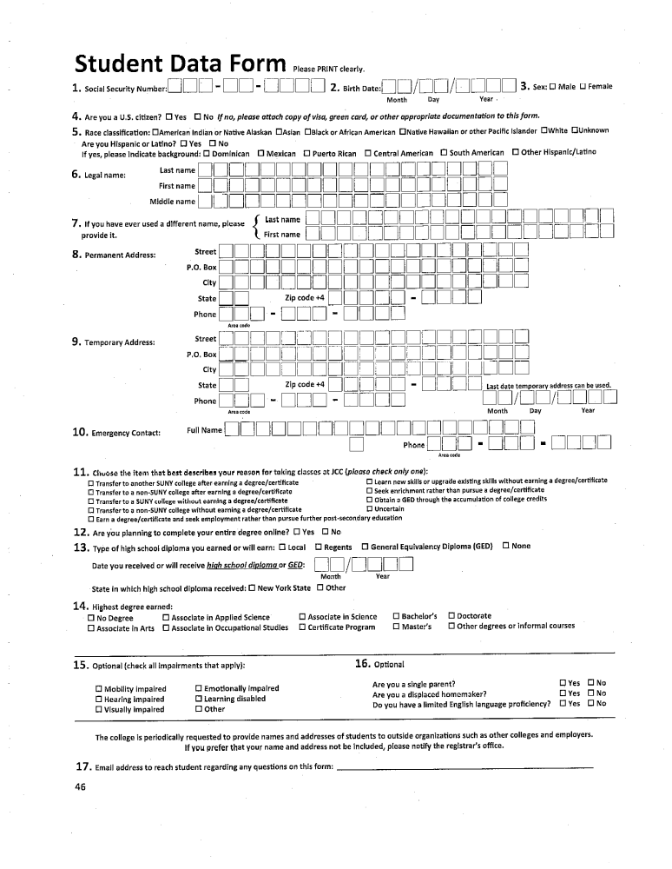

Immunizations required for Basic EMT Students

All questions are to be directed to the JCC Health Center at 716-338-1013 or 716-338-1077

Hospitals and EMT Class require:

• Physical within the past year
• 2 MMR’s or 2 Measles, 1 Mumps, 1 Rubella or positive titers
• PPD test negative within 6 mos

JCC requires:


